**Linear search**

***Linear search***, also known as ***sequential search***, is a straightforward algorithm used to search for an element in a list or array by checking each element one by one, from the beginning to the end, until the desired element is found or the list is exhausted.

**Steps in Linear Search:**

* Start from the first element of the list.
* Compare the current element with the target element (the one you're searching for).
* If the current element matches the target, return the index of the element.
* If the current element does not match the target, move to the next element.
* Repeat steps 2-4 until you either find the target or reach the end of the list.
* If the target is not found, return a message (or a specific value) indicating the target is not present in the list.

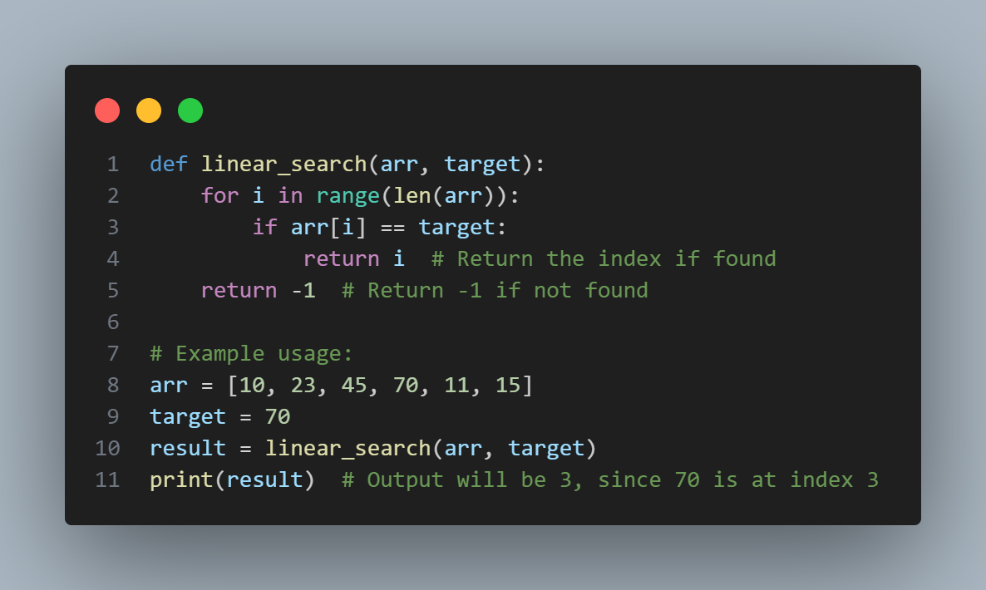

**Time Complexity of Linear Search**

**Best Case Time Complexity:**

* **O(1):** The best-case scenario occurs when the target element is at the first position of the list. In this case, the algorithm only needs to make one comparison, which is a constant-time operation.
* For example, if I want to search 10 from the above array then the 10 will be found at the first position, so the time complexity will be ***O(1)***.

**Worst Case Time Complexity:**

* **O(n):** The worst-case scenario happens when the target element is either at the last position of the list or not present at all. In such cases, the algorithm has to check all **`n`** elements, where **`n`** is the length of the list.

**Average Case Time Complexity:**

* **O(n):** On average, the target element might be somewhere in the middle of the list. On average, the algorithm will have to check about half of the elements, but in terms of Big-O notation, this is still considered ***O(n)***.

**Space Complexity of Linear Search**

* **O(1):** The space complexity of linear search is constant because the algorithm only uses a few additional variables to store the current index and the target element. No additional space is required that depends on the size of the input.

**Summary of Time Complexity:**

|  |  |
| --- | --- |
| **Scenario** | **Time complexity** |
| *Best case* | *O(1)* |
| *Worst case* | *O(n)* |
| *Average case* | *O(n)* |

Linear search is simple but not the most efficient for large datasets. For sorted data, other algorithms like binary search ***(O(log n))*** are typically preferred. However, linear search is applicable to both sorted and unsorted data, unlike binary search, which requires sorted data.

**Binary search**

***Binary search*** is an efficient algorithm used to find an element in a **sorted** list by repeatedly dividing the search interval in half. If the target value is less than the middle element of the interval, the search continues in the left half; otherwise, it continues in the right half. This process is repeated until the target value is found or the search interval is empty. Binary search follows the **`Divide and Conquer`** approach.

**Steps in Binary Search for normal way:**

* Start with two pointers, `low` and `high`, representing the start and end of the search range.
* Calculate the middle index `mid` of the current search range as:
$$mid=[\frac{low+high}{2}]$$

* Compare the element at the middle index **`arr[mid]`** with the target:
* If **`arr[mid]`** equals the target, return the index `mid`.
* If **`arr[mid]`** is greater than the target, set **`high = mid - 1`** and search the left half.
* If **`arr[mid]`** is less than the target, set **`low = mid + 1`** and search the right half.
* Repeat steps 2 and 3 until `low` exceeds `high`, meaning the target is not present.

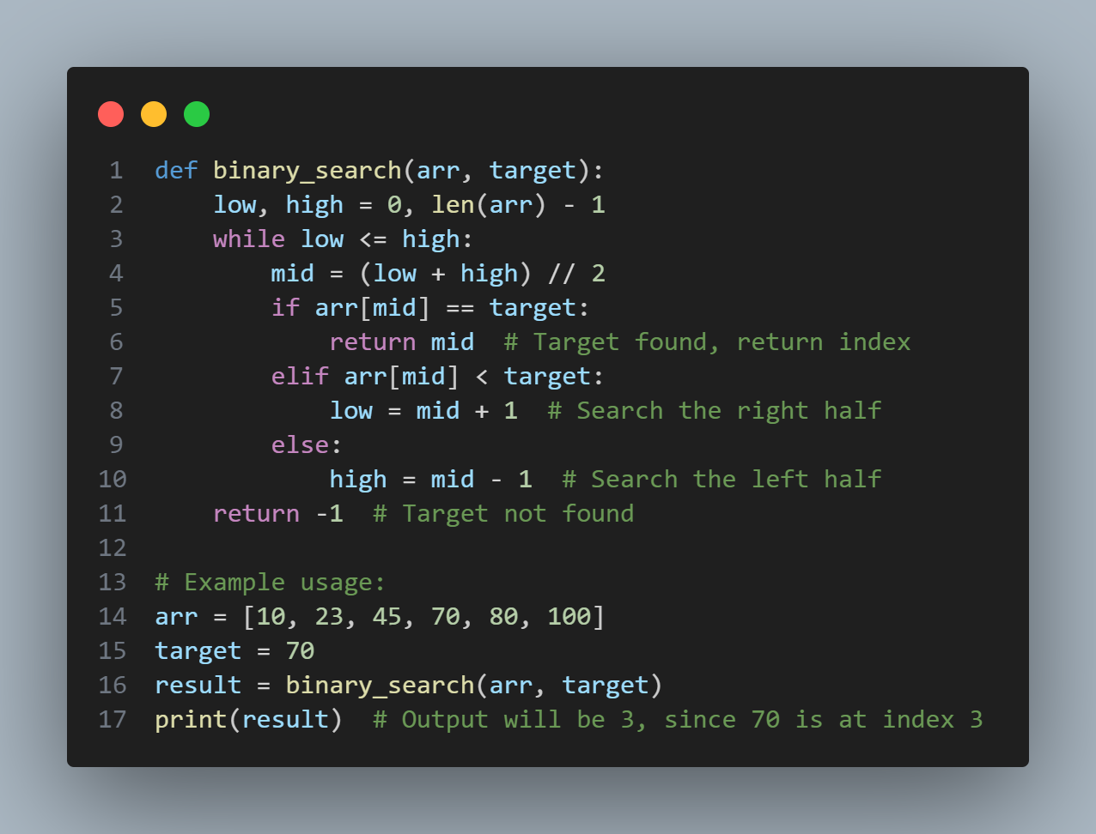

**Time Complexity of Binary Search**

Binary search is significantly more efficient than linear search for large datasets because it reduces the search space by half after each comparison.

**Best Case Time Complexity:**

* **O(1):** The best case occurs when the target is found at the middle index on the first attempt. In this case, the algorithm only needs to make one **`comparison`**, which is a constant-time operation.

**Worst Case and Average Case Time Complexity:**

* **O(log n):** In the worst case, binary search will repeatedly halve the search range until only one element remains. The number of steps required to reduce a list of size **`n`** to a single element is proportional to the base-2 logarithm of **`n`**.
* For a list of size `n`, the number of comparisons made is at most: ***log2 (n) + 1***

This is why the time complexity in both the average and worst cases is ***O(log n)***. In each iteration, the search space is reduced by half, which results in a logarithmic growth in the number of steps required.

**Explanation of Time Complexity:**

* **Best Case (O(1)):** The target is the middle element on the first comparison.
* **Worst Case (O(log n)):** In the worst case, the search space has to be halved repeatedly until only one element remains. The number of times you can halve a list of size **`n`** is the number of times you can divide **`n`** by 2 before you reach **1**. This is proportional to ***log base 2 of n***.
* **Average Case (O(log n)):** On average, binary search will locate the target after a few iterations of halving the list. Since the process is logarithmic, the average time complexity is also **O(log n)**.

**Example Time Complexity Breakdown:**

For a list of size `n = 16`:

* After 1 iteration, you check 8 elements (half the list).
* After 2 iterations, you check 4 elements.
* After 3 iterations, you check 2 elements.
* After 4 iterations, you check 1 element (or find the target).

In general, the number of iterations required is around ***log₂(n)***.

**Space Complexity of Binary Search**

**O(1)** for iterative implementations: The algorithm uses only a few extra variables ***(`low`, `high`, `mid`)***, so the space complexity is constant.

**O(log n)** for recursive implementations: In recursive implementations, each recursive call adds a new frame to the call stack, which requires ***(log n)*** space in the worst case.

**Summary of Time Complexity:**

|  |  |
| --- | --- |
| **Scenario** | **Time complexity** |
| *Best case* | *O(1)* |
| *Worst case* | *O(log n)* |
| *Average case* | *O(log n)* |

**Key Points:**

* Binary search is much faster than linear search for large, sorted datasets.
* It requires the array to be **sorted** for it to work correctly.